**ASSIGNMENT-5**

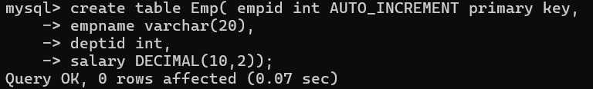

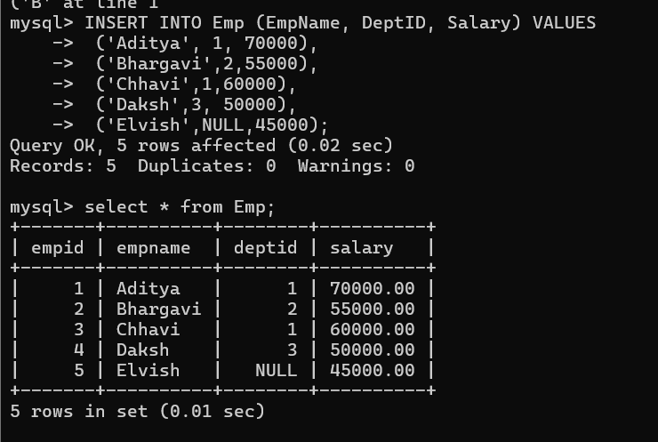

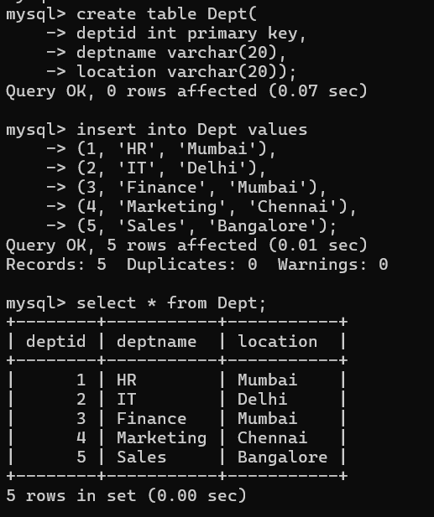

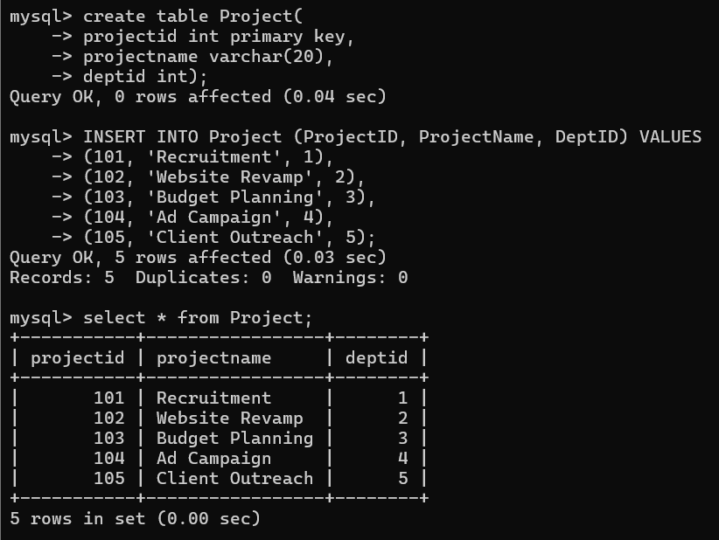

**---------------------------------------------------------------------------------------------------------**

1. Write a Relational Algebra expression to perform **Cartesian Product (Cross Join)** between Emp and Dept tables.

**Ans:-** To perform a **Cartesian Product** between the Emp and Dept tables in **Relational Algebra**, we use the **cross product operator (×)**.

**Relational Algebra Expression:**

$$\text{Emp}×\text{Dept}$$

**🔍 Explanation:**

* This operation pairs **every tuple** (row) from Emp with **every tuple** from Dept.
* The result will have a number of rows equal to:
$$\text{Number of rows in Emp}×\text{Number of rows in Dept}$$

* It’s useful when you want all possible combinations — or as a step before filtering with a SELECT (σ) operation.

--------------------------------------------------------------------------------------------------------------------------

2.Write a SQL query to perform an **INNER JOIN** between Emp and Dept tables displaying EmpName and DeptName.

Ans:-

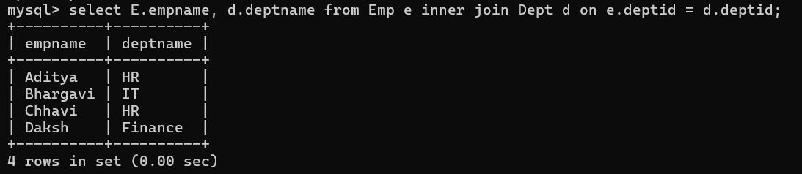

---------------------------------------------------------------------------------------------------------

1. Write a SQL query to perform a **LEFT OUTER JOIN** between Emp and Dept tables to display all employees along with their department information, including employees without a department.

Ans:-

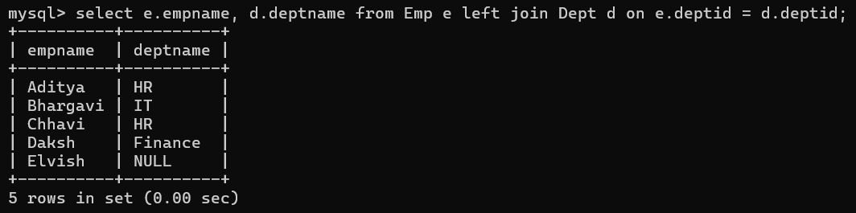

---------------------------------------------------------------------------------------------------

1. Write a SQL query to perform a **RIGHT OUTER JOIN** between Emp and Dept tables.

Ans:-

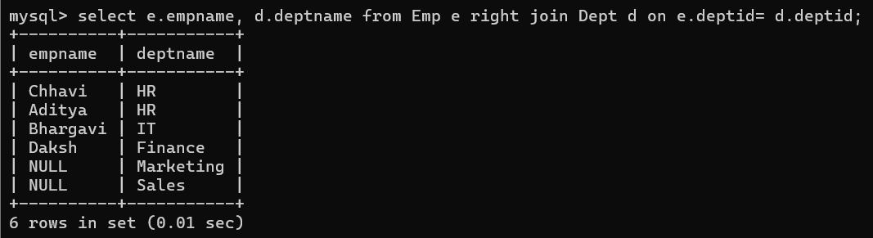

---------------------------------------------------------------------------------------------------------

1. Write a SQL query to perform a **NATURAL JOIN** between Emp and Dept.

Ans:-

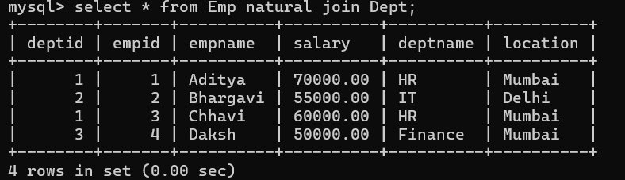

---------------------------------------------------------------------------------------------------------

6.Write a SQL query to perform a **CROSS JOIN** between Emp and Project table.

Ans:-

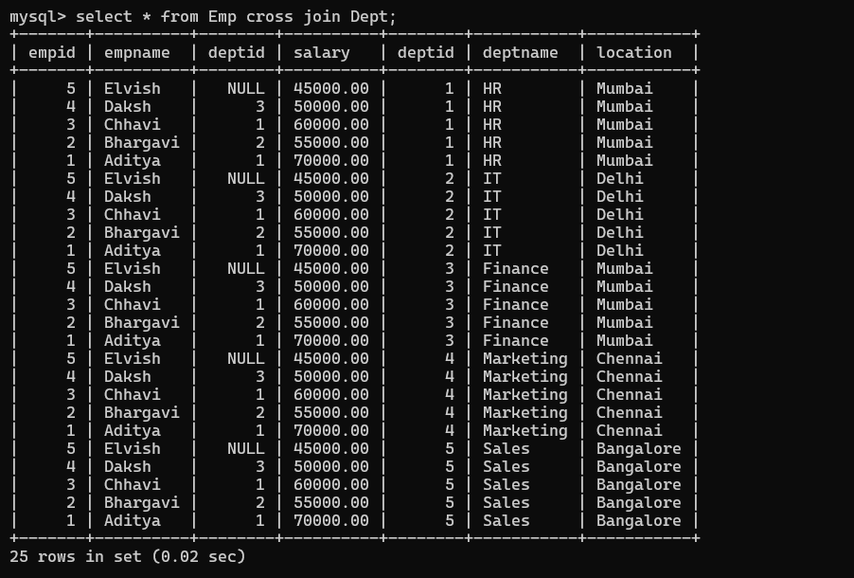

---------------------------------------------------------------------------------------------------------

7.Write a SQL query to **create a new table EmpBackup with the same structure as Emp but no data**.

Ans:-

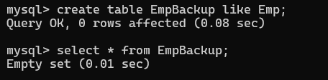

---------------------------------------------------------------------------------------------------------

1. Write a SQL query to **copy all data from Emp into EmpBackup table**.

Ans:-

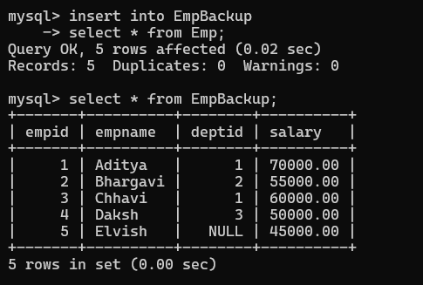

-----------------------------------------------------------------------------------------------------

1. Write a SQL query to **create a new table ProjectArchive with the same structure and data as Project**.

Ans:-

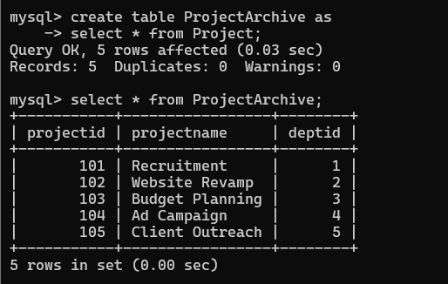

-------------------------------------------------------------------------------------------------------

10.Write a SQL query to create an **AUTO_INCREMENT sequence for EmpID in the Emp table** during table creation.

Ans:-

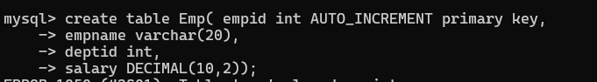

---------------------------------------------------------------------------------------------------------11. Write a SQL query using a **subquery** to find all employees whose salary is greater than the **average salary of all employees**.

Ans:-

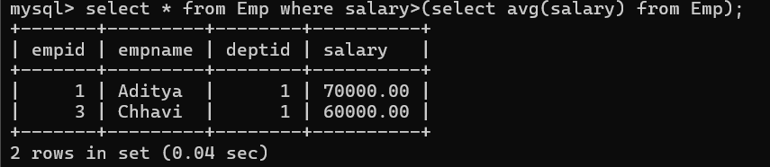

--------------------------------------------------------------------------------------------------------12. Write a SQL query using a **subquery in WHERE clause** to find employees working in departments located in 'Mumbai'.

Ans:-

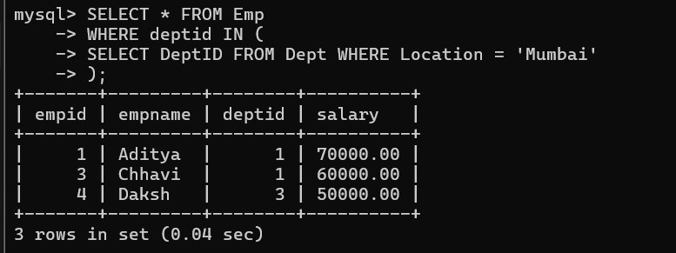

---------------------------------------------------------------------------------------------------------

13.Write a SQL query to display all departments where the number of employees is greater than **5**, using a subquery.

Ans:-

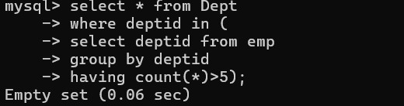

------------------------------------------------------------------------------------------------------14. Write a subqueries for find out Max salary of employee.

Ans:-

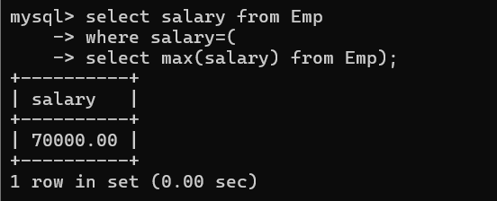

----------------------------------------------------------------------------------------------------15. 15. Write a self join query for each table.

Ans:-





